**Ideation Phase**

**Brainstorm & Idea Prioritization**

|  |  |
| --- | --- |
| Date | 15 June 2025 |
| Team ID | LTVIP2025TMID46365 |
| Project Name | Book Nest: |
| Maximum Marks | 4 Marks |

**Brainstorm & Idea Prioritization:**

Brainstorming provides a free and open environment that encourages everyone within a team to participate in the creative thinking process that leads to problem solving. Prioritizing volume over value, out-of-the-box ideas are welcome and built upon, and all participants are encouraged to collaborate, helping each other develop a rich amount of creative solutions.

Link: <https://app.mural.co/t/bookorder0417/m/bookorder0417/1750770438520/1047a88635c51a632439c81f8caa682712057c94?sender=u427be78f24cc5d79ea230073>

**Step-1: Team Gathering, Collaboration and Select the Problem Statement**

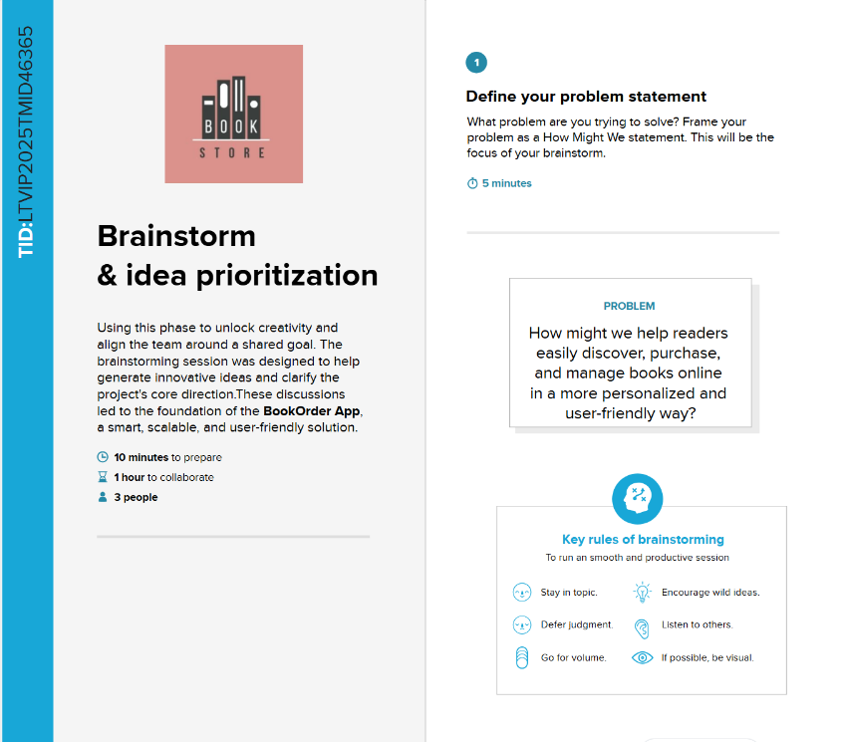

**Step-2: Brainstorm, Idea Listing and Grouping**

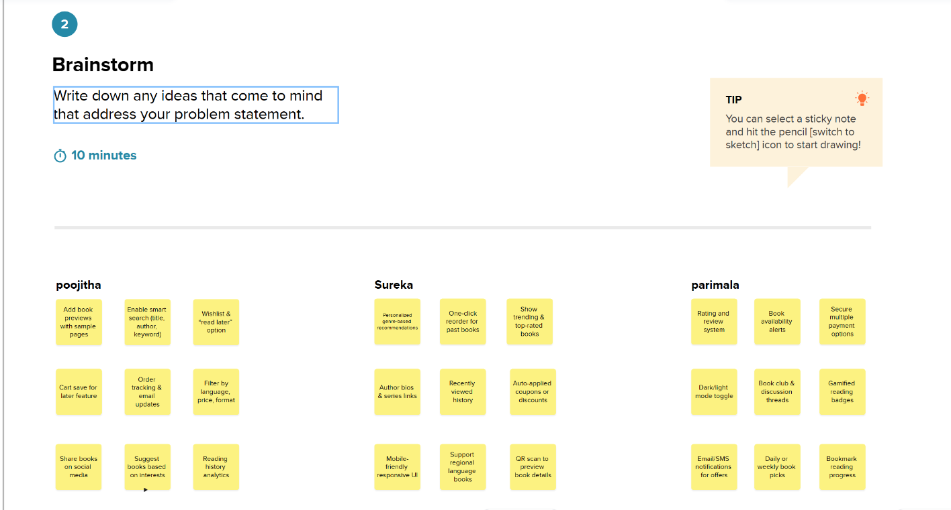

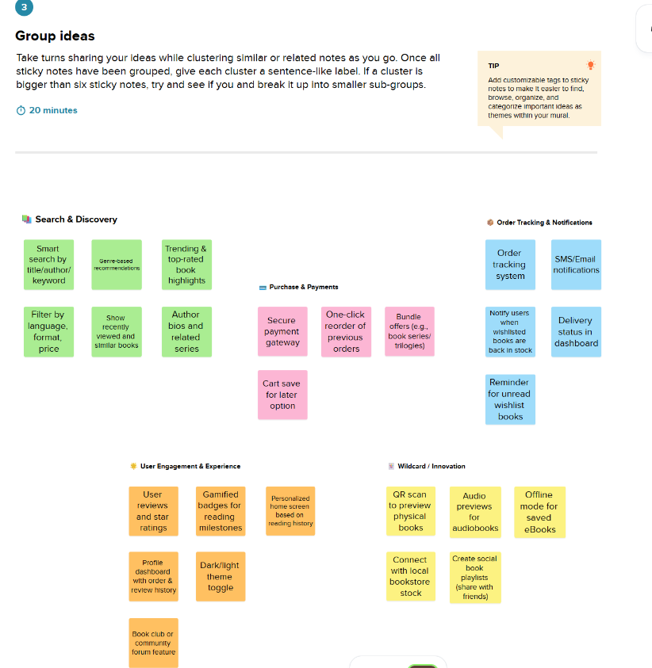

**Step-3: Idea Prioritization**